For website:  
About Us:  
For the globalization of internet & web based foundation it has become so near to reach the Door to Door to provide all kinds of support & service. Bright Studio Ltd is a company of web & internet base image editing service Provider Company which provides all kinds of image treatment. If you are familiar with this you will know the services like Photoshop Clipping Path, Photo Retouching, Image Masking, Color Correction, Photo Restoration, and Logo Design, Raster 2 Vector works, image editing and other creative design solution. We are here to fulfill the graphic design and

image editing needs for advertising agencies, magazines, newspapers, printing & publishing

companies around the globe. Bright Studio Ltd always ready to provide all Image Editing and Graphic

Design services as the way you want from us. You can easily differentiate us from other service

providers in terms of commitment, quality, time management, proper follow-up

within a very

competitive price. It is our mission to help ecommerce businesses sell more through their imaging.

● You need the best service, one that is fast and hassle free

● Clipping paths, photo masking, Photoshop retouching are just a few of the services you can

get with Bright Studio Ltd

● You are from America, UK, Canada, Japan, Australia or Russia. It doesn’t matter where

you are because your team of graphic designers is there for you any time of the day, any

day of the year.

● And you know the price you pay will be the best.

With Bright Studio Ltd your work is the center of attention: everything revolves around

it to make it perfect:

● More than expert

in house professionals are available to you.

● Any of the services you will expect from a Bright Studio Ltd at the reach of a click. Clipping

path included, of course.

● Expect responses within one hour: no matter when you send your request, there’s always

someone at the other end.

● At Bright Studio Ltd we use the latest graphic design software to ensure you always get the best

results.

● Get your money back if you are not happy with our service. We are risk free.

If you are looking for advice on your web images feel free to contact me. We can provide a

free evaluation of your website images and also sample images QA process.

**PORTFOLIO  
WE SPECIALIZE IN HIGH-QUALITY IMAGE EDITING SERVICES FOR E-COMMERCE  
  
 RECENT WORKS BY US  
  
  
  
 CONTACT US  
WE ARE KNOWN FOR THE BEST IMAGE EDITING AND BACKGROUND REMOVAL SERVICE PROVIDER**

**24/5- DAY SUPPORT & SERVICE  
We appreciate your desire to collaborate with Bright Studio Ltd. Please answer the questions below so that we can evaluate your project and requirements more thoroughly. Even though we're sticklers for specifics, we understand that you might not have all the information, and that's totally fine. Just fill out what you can, and we can talk about the rest later.**  **Have any questions!** [**info@brightstudioltd.com**](mailto:info@brightstudioltd.com) **Call us:  
 +0000000000000000  
 Website** [**www.brightstudioltd.com**](http://www.brightstudioltd.com)

**BANGLADESH BRANCH**

**Address: Dhaka, Bangladesh**

**Call: +………………..**

**Website:** [**www.brightstudioltd.com**](http://www.brightstudioltd.com)

**Email:** [**info@brightstudioltd.com**](mailto:info@brightstudioltd.com)

**Skype: ………………………..**

**UK BRANCH**

**Address: 134B New St Birmingham West Midland**

**Call:+ 447893929400**

**Email:** [**………………..**](http://www.brightstudioltd.com)

**AUSTRALIA BRANCH**

**Address: Sydney, Australia**

**Call: +61 491 570 156**

**Email: ………………..**

**SEND US A MESSAGE**If you got any questions,

Please do not hesitate to send us a message.

We reply within 30 minutes! **Name  
Email  
Phone  
Your Message   
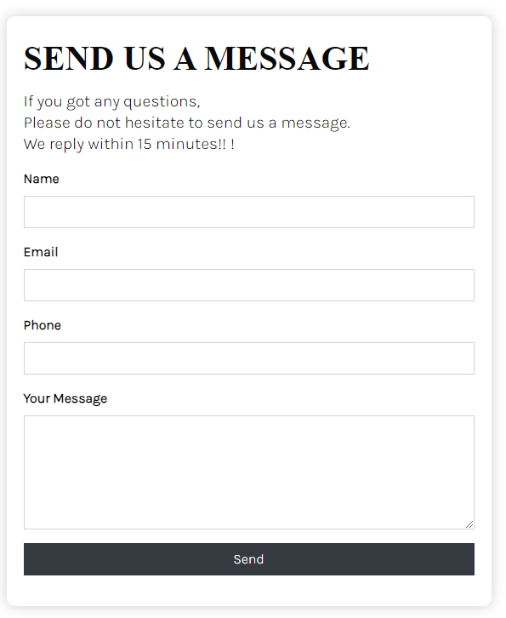  
  
 FREE TRIAL**LET'S CHECK OUR WORK!  
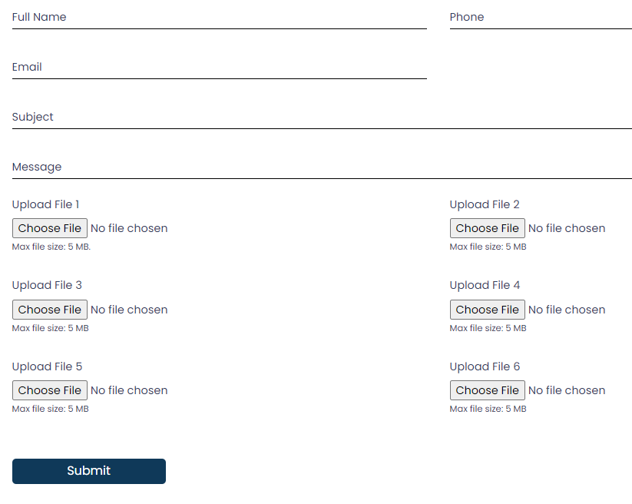 CHOOSE FILE 3 TA THE LE E HOBE  
  
 contexts, and Heading name  
 **BEST IMAGE EDITING SERVICE PROVIDER COMPANY WITH AN EXCELLENT TRACK RECORD   
 WHY CHOOSE US**We are experienced in providing all kinds of image editing services like Clipping Path, Background Removal, Image Enhancement, Image Masking, Image Manipulation, Photo Retouching, Neck Joint, Color Correction, Shadow Creation, etc. From bright studio ltd we always give priority to our clients. Our goal is to help our clients through our services. Our services come with the following things.  
  
Q. Reasonable Cost  
**Ans:** Our exclusive services come with very little cost. If you think image outsourcing is expensive then try us you will be amazed by our pricing. Get your quote from us today.  
  
Q. Exclusive Discount On 1st Order  
**Ans:**We have a 24/5 Day customer support team who we are always ready for your query. Our instant chat support and voice call will give you 100% satisfaction with our service  
Q. 3 Step Quality Control  
**Ans:** We have plenty of experienced designers who will implement all your idea into the photo. To give the best outcome we have 3 step quality control. We will ensure each and every need of yours in the image.  
Q. Easy Permanent System  
**Ans:** We let everything on to our clients regarding payments. You can pay whatever way you can. We are open to everything. You can pay via PayPal, Bank transfer, Check, etc. We accept Weekly, Bi-Weekly and Monthly Payments. You can choose whatever option is best for you.  
Q.100% Money Back Guaranteed  
**Ans:** We believe in quality work. Our job is to make you satisfied. You don't need to pay a cent until you're fully satisfied. So we will ensure the money back guarantee.  
Q. Free Trial Service  
**Ans:** We have free trial services which will help you to judge our work quality before start working with us. It will also help you to make the right decision.  
Q. Bulk Amount Discountee  
**Ans:** If you have a bulk amount of files and you’re worried about the cost we are here for you. We will offer exclusive package pricing for bulk images. Finding difficult to believe get your quote from us today.  
Q. Satisfaction Guaranteed  
**Ans:** Client satisfaction is the only thing we care about. We always work until our clients are happy. We believe in quality, not in quantity.

**Heading name, Card title and text, Button name**

# PRICE EXAMPLES

### Please note that the prices below are for guidance only. For all clients, we calculate a price per image based on the specific job task. CUT-OUTS Everything from simple cut-outs of products to advanced clipping tasks RETOUCHING Retouching, colour correction, contrast and brightness make your images crisp, HIGH-END RETOUCHING High-end retouching includes advanced adjustments where items are replaced, removed, or added COLOUR CORRECTION Colour correction ensures a consistent expression, even though the starting point may require some improvement Example Skin shoot bellow Heading name and image WE ARE SPECIALIZED IN HIGH-QUALITY E-COMMERCE IMAGE EDITING SERVICES OUR RECENT WORKS Heading name and timages PHOTO RETOUCHING SERVICE PROVIDER OUR OUTSTANDING SERVICES WILL HELP YOUR BUSINESS GROWTH

Our services:  
We have a highly talented graphic team to provide you high quality service. We are very much

professional and dedicated to our clients. We ensure our clients to deliver our service on time at

the affordable rate you deserve. We do not compromise on the quality of work which is the best

part of our service.

**01 Cut Outs Background Removal**

Background removal in photo editing is the process through which an object is isolated from it’s

background. This technique is very effective in removing the main object from that which surrounds

it and is based on the clipping path. Remove background from image basically changes the whole

image. Background removal is a frequently used image manipulation technique, used to erase the

unwanted backdrop

or object from the image. Think about you snap a shot of a product where a

number of other substances exit what you never mean to show; especially this happens when

you’re doing marketing for your product in an ecommerce

site. Bright Studio Ltd have experienced

designer for removing background.

**02 Clipping Path**  
Clipping Paths are used to outline objects from the background of an image. These objects are

offered a different background. A clipping Path is a vector path which allows part of an image to

show while hiding the rest effectively rendering part of the image transparent. Generally, it means

a hardedged

vector masking technique that improves the desired areas of the image and covers

the unwanted image elements.  
  
**03 Symmetric Shaping & Wrinkles Remove**Bright Studio Ltd is known among customers as a business that is aware of the strategy needed to produce a high-quality Symmetric Shaping & Wrinkles Remove for clothing.Anyone who needs Symmetric Shaping & Wrinkles Remove services can get them from us. The following list includes some of the industries that frequently need Symmetric Shaping & Wrinkles Remove services.

❏ GARMENTS INDUSTRY:

Take our ghost mannequin if you work in the garment industry.

APPAREL INDUSTRY:

Taking our ghost mannequin is a good idea if you work in the apparel industry

❏ ECOMMERCE INDUSTRIES:

Service for neck joints is crucial for e-commerce sectors. Therefore, if you run an online store or work there, you must perform a lot of editing every day. Many of the photographs you edit on a daily basis will need Symmetric Shaping & Wrinkles Remove services

❏ PHOTO EDITING AGENCY:

On a daily basis, several photo editing companies use our services. All forms of photo editing, including Symmetric Shaping & Wrinkles Remove correction, are required.

❏ PROFESSIONAL PHOTO EDITOR:

Professional photo editors will undoubtedly want Symmetric Shaping & Wrinkles Remove services for a variety of reasons. Services for the neck joints can save a ton of time and effort.

❏ PROFESSIONAL PHOTOGRAPHERS :

A professional photographer requires absolute perfection. They are unable to offer any justifications. A professional photographer must offer Symmetric Shaping & Wrinkles Remove or ghost mannequin service if they want to deliver exceptional customer service and satisfy clients. Therefore, they can undoubtedly attempt our Symmetric Shaping & Wrinkles Remove service. **04 High -End Model Retouching**when your best shot image needs extra appeal, High End Photo Retouching becomes crucial. Wedding photographs, ads in magazines, photos for fashion publications or luxury magazines, real estate photographs, and a lot of other photographs require this high-end retouching service. During regular retouching, you lose a lot of details in pixels, but in high end portrait and beauty retouching, you may need non-destructive photo retouching to get a more natural looking photos. High End Photo Retouching is the most advanced type of retouching technique that involves analyzing, contouring, removing imperfections, smoothing textures, dodging and burning, and many more.

The traces of retouching in the final output is relatively untraceable. In most cases, it is performed with Pen Tablets (Wacom), sophisticated imaging technology, advanced Photoshop tools, and most of all precious attention, effort, and time of a professional retoucher. Such high end service requires sweat, but has sweet return. One single retouching work requires more than an hour of very attentive and detailed work. That’s why our professional high end retouching service is one of our most expensive services. However, as our base price is very competitive, therefore we can provide the best quality at the best price in the market.

The biggest challenge for a photographer, is spending time, attention, and energy on retouching images. But, it is always best to outsource your time, attention, and energy to a company that can ensure peace of mind by providing better retouching solution with sophisticated retouching techniques and technologies. Are we that solution? Well, you don’t have to believe our words or the sample pictures below. You be the judge. Send us images for a free trial.

**05 Product Photo Retouching**The photos those have faded and you want to make it looks good as the first time the photos were

taken. This is the great idea since the old photos are commonly faded, darkened and probably

discolored with age too. By using latest software, we will help you to repair and restore your

precious photographs easily. Photographs are a great way to keep those special memories,

wedding, anniversary, birth, and family or friends reunion and many others. Sometimes however,

those precious memories are damaged or degrade over time due to dereliction of photos. Earlier,

when there were no restoration services available, the changes were made to the original

photograph and even till today it’s the preferred method for preserving old, historical photographs.

But nowadays, it’s easier to work on the restoration part, as the changes are made to the copy of the original photo.

**06 Jewelry Retouching**Professionally retouching jewelry photos attract the most potential buyers and present precious gemstones in the most shining and appealing way. After being retouched by Photoshop, various jewelry pieces including rings, earrings, necklaces, etc. gleam. **07 Model Photo Liquefy & Retouching**High-End Model Photo Liquefy Retouch is an excellent technique of image manipulation that helps you to touch specific undesirable factors into your image. It gives your Model images a fresh, nice, and creative look. Photoshop Retouching Service provides us with some benefits. Removing unwanted objects from a photo, Adding a suitable object to a photo, Making a creative look of the photo frame, restoring the images for the future, and processing image manipulation **08 Image Masking**

Clipping Mask by Photoshop requires brilliancy in techniques and skills in precise image masking

tasks like Erasing and Regular Masking, Channel Masking, Color Masking, Color Masking, Layer

Masking, Transparency Masking and Alpha Masking. Providing accurate masking to any kind of

complex images are our expertise and that is why we are confidently serving all the industry

leaders like Print Media, Advertising Agency, Press, Store Chains, Franchise Companies, Online

Retailers and so on. Our experienced and world-class

designers ensure precise isolation of

images with subtle edges along with covering all the aspects of Photoshop image masking

services. Our photo masking technology will help you to reduce your overall cost by processing

bulk amount of photos at a time at precisely and within your lowest budget ever.  
**09 Natural Shadow**Shadowing an image can double the beauty of an image and give natural essence to it, that’s why

you’ll find shadowing very common and muchpracticed

image manipulation technique. In

ecommerce

site shadowing is needed so frequently to bring natural mood to the products.

We basically deal with two types of image shadowingdrop

shadowing and reflection shadowing

and for both of the services we have costeffective

packages for you. And we do say itwe’re

definitely the best provider of this service. Why? Because our highly professional art directors use

the latest software’s for shadowing the images our clients give to us.  
**10 Color Correction**   
Making color correction in Photoshop is to understand how color works with digital images. For

doing this we have to make creative images work with the adjustments in several scenarios. It has

to be remembered that we have to fix overall tonal and color problems in images. The main

purpose of Adobe Photoshop is to function as a digital darkroom in which images can be modified,

corrected and enhanced. Photoshop color correction service includes using of channels and

histograms for identifying problem areas. Applying adjustments like Curves and White Balance.

Making edits which changes the entire effect of the image. New user’s faces a difficult time while

correcting color or enhancing images. The main purpose of color correction is to make the image

look better. For color correction need to create multiple clipping path for better color separation. In

most cases they move far away from the target while fixing the images. Given below are some

guidelines to get started

**11 Color Changing**The majority of wedding celebrations are now organized by event management companies. One of the most crucial aspects of the events is photography. The event is more memorable and the clients are most satisfied with good photos. However, the lighting situation for photography is frequently inaccurate. They must therefore alter their photographs by using a color Changing service.

E-commerce businesses require color- Changing services for their images. Alibaba, Amazon, Shopify eBay, and Etsyetcare all required perfect catchy pictures to impress their buyers. **12 Reflection Creation**A proper reflection creation service is said to be done only when proper layer is made, image

transforming and flipping is clearly done, gradient is properly implemented, correct opacity is

maintained, and the shape remained exact. Our CPF Photoshop image reflection creation team is

high above the industry standard and committed to output you the most précised images your

business needs  
**13 Neck Joint Ghost Mannequin**Ghost mannequin is mainly applicable on garments and is commonly used in garment industry.

Ideally there are two or three parts which must be combined. There is the front part, the inner part

and the back part. The inner part can be created by combining the front part and the back part.

This is what will enable you have a complete image.

Neck join services may include image editing of garments such as the sweaters, tshirts,

and

shirts. If you have the front part and the back part, it is possible to combine the two parts to create

a real object using the neck joint technology. If you sell garments, it is possible to use the neck joint

technology to get images you can use on your website.

**14 Image Manipulation**Image manipulation is a kind of art which is actually altering a photo for expressing the necessity

of a person.This is another process that is related to the photo editing.This is applied for artistic

reason and also for deceitfulness.This also helps in resizing photos.There are different

applications for doing this and adobe photoshop is very popular among them.

**15 Multiple ClippingPath**Multi Clipping Path is used for those images that require isolation of parts. It is done to separate

some parts of the image to later change it in Photoshop. We are reliable and skilled clipping path

service provider from Bangladesh that provide image background removal services with

perfection. Do not take the pressures of editing or clipping images all by yourself. We are here to

give you the best multi clipping path services with utmost care. Let us omit those improper

outlining made on the product photographs and save yourself from getting adverse effect on your

growth graph. Our way of presenting your image is out of ordinary as we can give clarity to your

photographs by focusing on the object you need to market.

**16 Pattan Chinge**  
Ensure your product and garments matches perfectly with a swatch or reference image. Swatches and reference Images can be easily uploaded

into the bright studio ltd platform to make texture replacement you will reduce product and garments returns when a product does not Mach the

Texture seen in the product image of the online store.

**17 Raster to Vector Conversion**

Raster to Vector conversion means to convert raster images to vector images. But what's

significant is to know, what precisely is raster and vector, and why this conversion is so much

required after.

Images are of two types Raster and Vector. Normally, for any small sized image it doesn't make

much dissimilarity if the type is raster but if same image is enlarged without converting from raster

to vector it will give out an unclear picture. The reason behind this is, with raster images are made

up of dots which when enlarged gets mixed up. Whereas, with vector images are made of lines,

curves etc. and hence when it is enlarged these doesn't mix up; they just increase in size keeping

the image as it is.

Raster to vector is adapted to vectorize graphics for resizing and better usage, and there is usually

no change in actualization affianced in this process. Raster to vector conversions is acclimated on

photographs in adjustment to change their actualization into an exhausted or corrective one. One

of the functions of the raster to vector conversion is that it can accommodate a photograph into a

geometric design.

For that reason it is logically used for a lot of motives for example computer aided engineering,

finite element analysis, computer aided manufacturing, numerical control, photo realistic rendering,

document management and finally raster to vector conversions. Another worth mentioning usage

of computer aided design is that it can be used for the accurate creation of photo simulations in

style.  
**18 Real Estate Photo Editing & Retouching Services**  
Bright Studio Ltd is now the number one real estate photo editing service with 100+ satisfied customers worldwide. We have been editing real estate photos for 5 years has assisted people in buying, selling, or renting buildings through professionally edited photos. Let us help you create a dream home with the help of real estate retouching.  
  
DAY TO DUSK - FROM €4 PER PHOTO  
  
REGARDLESS OF THE TIME WHEN YOU TOOK YOUR REAL ESTATE PHOTOS, WE CAN MAKE THEM LOOK AS IF THEY WERE TAKEN IN THE EARLY MORNING, MIDDAY, OR LATE IN THE EVENING.  
BRIGHTNESS AND CONTRAST ADJUSTMENT  
Incorrect contrast and brightness settings can ruin even the most elaborate interior design composition. We can take care of such issues and give your property images a well-balanced look.  
How Does It Work  
❏ Upload real estate photos

### ❏ Write recommendations

### ❏ Submit for revision if necessary

### ❏ Get your photos back

Having received thousands of requests from realtors and photographers, we launched our own new real estate photo editing services. Either expert or beginning photographers can use it.

We will take care of your property photos in a fast and efficient way. Our services are a straight way to professional property photography.

**19 3D 360° Packshot Retouching**360-item photography can undoubtedly result in increased profits and advantages for your e-commerce organization when the aforementioned factors are taken into account. It would be best to board at this point.

So if you need 360-degree image editing, Studio Click House can assist you in providing it. Our skilled designers are knowledgeable in all 360-degree image editing techniques. We charge a very low price for this service as well.  
  
  
OUR 360-DEGREE IMAGE EDITING SERVICES INCLUDE:  
❏ Photo stitching services.

❏ HDR panorama enhancement.

❏ 360 spherical panoramic views.

❏ Inner/Outer sphere panorama.

❏ Inner/Outer cylinder panoramic view.

❏ 360-degree virtual tour services.

❏ Real estate panorama stitching services.

❏ Image blending services.  
  
**20 Photo Restoration**Professional photo restoration is another area of expertise at Bright studio ltd. Our Photo Restoration Service is also our most popular level. We restore any type of photograph that has been harmed by fire, light, water, mold, animals, or kids. Just give us the area of the image that matches the original. Our specialists are highly regarded for their work in advanced photo restoration. Unwavering excellent quality and service are the cornerstones of our productivity. Our devoted and effective team restores photos for individuals, organizations, and outstanding event photos using the most cutting-edge hardware & software. We can give you a duplicate of your damaged image that appears to be the original using digital technology, professionalism, experience, and background in fine art. You won’t notice even the slightest difference from the original image thanks to the excellent skill of our team for digital photo restoration service.

For commercial photographs, we digitally alter or restore vintage photos. We can also restore damaged photos to their original state by using the original photographs that were previously captured.

The computer has no magic but artists use a computer as the artist's tool. We employ the kind of artists who can envision your needs. When you compare it to other expenses, especially those related to a memorable event, you will see that it is more affordable than you initially thought. Your enjoyable time can be forgotten forever, however, these pictures can help you relive that happy moment.

Simply upload these types of images to get an estimate of the cost. Some photos contain special recollections that are the only photos that have survived for many years in your family but are in poor condition. We'll send you the updated pictures back.  
  
**WHAT DO WE CARRY OUT?**  
We remove stains, cracks, fold marks, stains, impregnation, and residues from the photos.

To make a photograph look brand-new, we restore faded color tints and tones.

We eliminate the yellowness and restore the color balance.

We adjust the image's sharpness, brightness, and contrast so that it has genuine color.

To give any image a realistic appearance, we also replace any missing pixels or pieces.

Before beginning the projects, we obtain some photographs that are required to apply complicated photo restoration services, in this example after consulting with a customer. So, if you're interested in this kind of service, just get in touch with us.  
  
  
 IF Possible 1 Button Add   
 **WORKFLOW**Our customer support team is available 24 hours a day and you can expect a replay within 30 minutes! Now you can contact us at any time 24/7- 365 days.

Our process is quite straightforward. We made things simple for the clients. We take care of everything for you so you can comprehend the entire process. Uploading photos is the first step in our process. You can use your favorite media to post your photographs whenever it is convenient for you. Everywhere we transfer to Dropbox, we are accessible.

A secure File Transfer Protocol (FTP) server is another tool we use. Since we know how much your reputation means to you, we always use the safest manner. Additionally, you can submit photographs in any format. Every format is one that we are familiar with. We begin working on it once we have your photographs. We always value your advice because it enables us to provide the ideal photo. We take all the required actions to finish the photo. We employ custom picture editing and AI technology to give an image a more prosperous vibe. We currently employ the most effective hardware and software, which allows us to complete our tasks more quickly. We delivered the finished photographs to our Quality Assurance Department  
  
We practice three-step quality control. The greatest quality will be guaranteed for you by their extensive experience. We review the photographs once they have been authorized by our three-step quality control team. We submit the photographs to your specified location once the review is finished. Through email, we immediately inform our clients when their files are returned. By delivering you the files, we do not complete our task. We are open to any adjustments or recommendations you may have regarding any photograph. According to your instructions, we will make the necessary corrections and resend the file in the same manner. This is how we interact with our customers.